Analysis Specifications

Version Number: | Version 1.0
Analysis Name: | AE Severity Analysis Panel
Engine Type /  Engine Version | SAS 9.2  Excel
Analysis Overview | The AE Severity Analysis Panel provides the user with different analyses to help understand the adverse events present in the study and the frequency of their occurrence by treatment arm. Statistical and frequency reports are generated to provide the user with needed information.  The Adverse Event analysis panel generates three separate Excel workbooks.  - Adverse Events Counts: provides various combinations of counts and percentages of most frequent adverse events and serious adverse events by treatment arm  - Adverse Events Relative Risk: provides a listing of the relative risk of adverse events between arms with their corresponding confidence intervals  - Adverse Events Odds Ratio: provides a listing of odds ratios of adverse events between arms with their corresponding confidence intervals
Analysis Description: | The AE Severity Analysis Panel contains three workbooks each with multiple analyses as listed below.  Workbook #1 Analysis Events Counts:  1: Adverse Events by Arm Greater than 2%  By arm, this analysis provides a table that lists the number of subjects and percent of subjects for each Adverse Event. The list is filtered to those adverse events whose percent is greater than 2% in any arm.  2: Serious Adverse Events by Arm  By arm, this analysis provides a table that lists the number of subjects and percent of subjects for each Adverse Event that was considered serious.  3: Adverse Events by Severity and Arm  By arm, this analysis provides a table that lists the number of events for each Adverse Event by severity level.  4: Serious Adverse Events by Severity and Arm  By arm, this analysis provides a table that lists the number of serious events for each Adverse Event by severity level.  Workbook #2 Adverse Events Relative Risk:  For each combination of arms, a table listing the adverse events with the top 30 relative risk along with the lower and upper confidence intervals is provided. The table also provides the count and percent of total by arm for each Adverse Event. Finally the analysis also creates a confidence interval plot.  Workbook #3 Adverse Events Odds Ratio:  For each combination of arms, a table listing the adverse events with the top 30 odds ratio along with the lower and upper confidence is provided. The table also provides the count and percent of total by arm for each Adverse Event. Finally the analysis also creates a confidence interval plot.
Precondition(s): | The Adverse Event Analysis has the following preconditions:  - A Demographics (DM) dataset has to exist according to CDISC SDTM format specifications  - The Demographics variables actual arm (ACTARM) or planned treatment arm (ARM) and subject id (USUBJID) must be present.  - Planned arm code (ARMCD), subject reference start date/time (RFSTDTC), and subject reference end date/time (RFENDTC) will be used if present but are not necessary  - An Adverse Event (AE) dataset has to exist according to CDISC SDTM format specifications  - The Adverse Event variables subject id (USUBJID), body system or organ class (AEBODSYS), and dictionary derived term (AEDECOD) must be present  - Severity/intensity (AESEV), serious event (AESER), and adverse event start date/time (AESTDTC) will be used if present but are not necessary  - An Exposure (EX) dataset has to exist according to CDISC SDTM format specifications  - The Exposure variable subject id (USUBJID) must be present in the EX dataset  - Exposure start date/time (EXSTDTC) and end date/time (EXENDTC) will be used if present but are not necessary
Panel Options: | The following is a list of topics and values that the user is required to enter from the panel options page of the Script Launcher. The value chosen will be used in the analysis:
  Topic | Possible Values | Default
  End Day for Study Analysis | Numbers 0 - 60 | 30
  Continuity Correction | None, 0.5, 1, 1/Other Arm Count | 1
Input from: | The datasets required to perform the Adverse Event analysis are chosen by the user and provided by the Script Launcher. The panel options described above are used as inputs in the analysis.
Input(s): | The Adverse Event Analysis uses the following data and variables:  - DM –  - ACTARM  - ARM  - ARMCD (optional)  - USUBJID  - RFSTDTC (optional)  - RFENDTC (optional)  - AE –  - AEDECOD  - AEBODSYS  - AESEV (optional)  - AESER (optional)  - USUBJID  - AESTDTC (optional)  - EX –  - USUBJID  - EXSTDTC (optional)  - EXENDTC (optional)
Process Flow: | The process flow diagram below provides the user a graphical representation of the Adverse Event Analysis steps.  Data Pre-processing  DM  EX  DM_EX  USUBJID  ACTARM  EXSTDTC/  RFSTDTC  EXENDTC/  RFENDTC  AE  USUBJID  AEBODSYS  etc.  AESTDTC  AE_DM_EX  where AE.USUBJID = DM_EX.USUBJID  and AESTDTC between STDTC and ENDTC  Analysis 1: Adverse Events by Arm Greater than 2%  AE_DM_EX  DM_EX  USUBJID  ACTARM  AEBODSYS  AEDECOD  Count of USUBJID  per AEBODSYS/AEDECOD  per ACTARM  USUBJID  ACTARM  Count of USUBJID  per ACTARM  Percentage of USUBJID  per ACTARM  with AEBODSYS/AEDECOD  Filter Percentages <= 2%  Output to Excel Spreadsheet  Analysis 2: Serious Adverse Events by Arm  AE_DM_EX  DM_EX  USUBJID  ACTARM  AEBODSYS  AEDECOD  Count of USUBJID  per AEBODSYS/AEDECOD  per ACTARM where AESER=Y  USUBJID  ACTARM  Count of USUBJID  per ACTARM  Percentage of USUBJID  per ACTARM  with AEBODSYS/AEDECOD  where AESER=Y  Output to Excel Spreadsheet  AESER=Y  Analysis 3: Adverse Events by Severity and Arm  AE_DM_EX  AEBODSYS  AEDECOD  Count of AEBODSYS/AEDECOD  per AESEV  per ACTARM  ACTARM  AESEV  Output to Excel Spreadsheet  Analysis 4: Serious Adverse Events by Severity and Arm  AE_DM_EX  AEBODSYS  AEDECOD  Count of AEBODSYS/AEDECOD  where AESER=Y  per AESEV  per ACTARM  ACTARM  AESEV  Output to Excel Spreadsheet  AESER=Y  Odds Ratio/ Relative Risk  AE_DM_EX  DM_EX  USUBJID  ACTARM  AEBODSYS  AEDECOD  Count of USUBJID  per AEBODSYS/AEDECOD  per ACTARM  USUBJID  ACTARM  Count of USUBJID  per ACTARM  Percentage of USUBJID  per ACTARM  with AEBODSYS/AEDECOD  Odds Ratio/Relative Risk  Standard Error  95% Confidence Interval  Output to Excel Spreadsheet
Requirements: | The Adverse Event analysis shall perform and execute the following steps within the prescribed order:  Data Pre-processing:  - Identify the Adverse Events, Demographic, and Exposure Datasets.  - Determine whether the Adverse Events, Demographics, and Exposure Datasets are in the prescribed CDISC SDTM format and whether the variables within the Dataset comply with CDISC SDTM standards.  - Adverse Events AE  - Demographics Dataset DM  - Exposure Dataset EX  - Determine whether the needed Demographic variables are present within the Demographics Dataset (DM).  - If ARMCD exists then if ARMCD is equal “SCRNFAIL” or “NOTASSGN” then delete  - If ACTARM exists, then use it as the subject’s arm, otherwise use ARM  - ACTARM  - ARM  - ARMCD (optional)  - USUBJID  - RFSTDTC (optional)  - RFENDTC (optional)  - Determine whether the needed Adverse Events variables are present within the Adverse Events Dataset (AE).  - AEDECOD  - AEBODSYS  - AESEV (optional)  - AESER (optional)  - USUBJID  - AESTDTC (optional)  - Determine whether the needed Exposure variables are present within the Exposure Dataset (EX)  - USUBJID  - EXSTDTC (optional)  - EXENDTC (optional)  - If all required variable are present, proceed.  - Find all distinct subjects (USUBJID) in EX. This is the safety population  - Find the earliest exposure start date (EXSTDTC) and the latest exposure end date (EXENDTC)  - Join DM and the distinct USUBJID of EX found above and keep those observations where  - USUBJID is in both  - The subject’s planned arm code (ARMCD in DM) is not ‘NOTASSGN’ or ‘SCRNFAIL’  - If EXSTDTC and EXENDTC exist and the subject has exposure start and end dates from EX, use those as the subject’s treatment start and end dates. Otherwise, if RFSTDTC and RFENDTC exist, use the subject’s reference start and end dates (RFSTDTC and RFENDTC). If date variables exist but a given subject has no dates, exclude them from the analysis.  - The observations found here will be henceforth referred to as DM_EX.  - Join AE and DM_EX by USUBJID and keep those observations where  - USUBJID is in both  - If EXSTDTC and EXENDTC or RFSTDTC and RFENDTC exist then check to see if the adverse events happened during the study window by comparing their start dates to the subject’s treatment dates  - The start date of the adverse event (AESTDTC in AE) must be equal to or after the subject’s treatment start date and before or equal to the subject’s treatment end date + the number of days specified by the user afterwards  - These date/times are stored in text as ISO 8601 format.  - If the length of the string is 10 or greater, it will contain year, month, and day.  - Otherwise, if the length of the string is 7 or greater, it will contain only year and month. In this case, extract the year from characters 1 to 4 and the month from characters 6 to 7 and assume day 1 for all dates being compared. Add to the treatment end date the number of months given by the floor of the number of days afterward divided by 30. For example, if treatment start and end date are 2010-01-15 and 2010-06-30, the adverse event start date is 2010-01, and the user chose a 30 day lag, then the adverse event would have start date 2010-01-01, which falls between 2010-01-01 and 2010-07-01.  - If the string has length less than 7, the subject or adverse event cannot be used.  - The observations found here will henceforth be referred to as AE_DM_EX  Analysis 1: Adverse Events by Arm Greater than 2%  - This analysis lists how many subjects experienced each adverse event per arm and what percentage of the arm that represents. The list is filtered to those adverse events where more than 2% of the subjects in any arm experience it at least once  - Using dataset AE_DM_EX found in 1.8, find the count of subjects experiencing each adverse event (AEBODSYS/AEDECOD combination) by arm (ACTARM or ARM)  - The formula for the count of subjects experiencing a given adverse event AE in a given arm is as follows  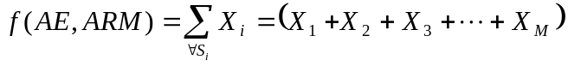  where  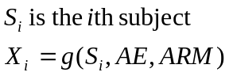  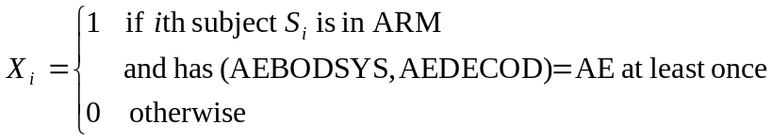  - Note that each subject is counted only once per adverse event, even if they have more than once occurrence of the same adverse event  - Using dataset DM_EX found in 1.7, find the count of subjects (USUBJID) per arm (ARM)  - The formula for the count of subjects in a given arm is as follows  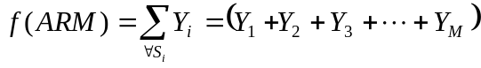  where  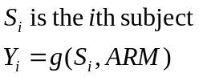  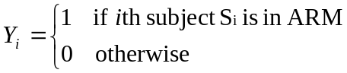  - Using the counts of subjects experiencing each adverse event per arm found in 2.1 and the counts of subjects per arm found in 2.2, find the percentage of subjects experiencing each adverse event per arm  - The formula for this percentage for a given adverse event AE and arm is as follows  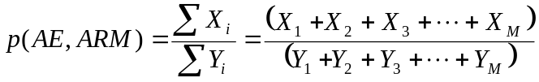  where X and Y are defined as above  - Find counts of subjects experiencing each adverse event across all arms, using the following formula  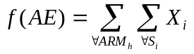  where ARM_{h} is the hth arm and the inner summation is as defined in 2.1  - Find percentages of subjects experiencing each adverse event across all arms  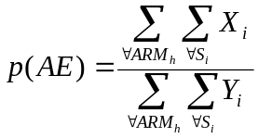  where ARM_{h} is the hth arm and the inner summations are as defined in 2.1 and 2.2  - Keep only adverse events where the percentage found 2.3above is greater than 2% for at least one arm  - Export the results to an Excel spreadsheet listing each adverse event and its counts and percentages by arm  Analysis 2: Serious Adverse Events by Arm  - This analysis lists how many subjects experienced each adverse event per arm where the occurrence was considered a serious event and what percentage of the arm that represents.  - Using dataset AE_DM_EX found in 1.8, find the count of subjects experiencing each adverse event (AEBODSYS/AEDECOD combination) where the occurrence was considered serious (AESER=‘Y’) by arm (ACTARM or ARM)  - The formula for the count of subjects experiencing a given adverse event AE where the occurrence was considered serious in a given arm is as follows  where  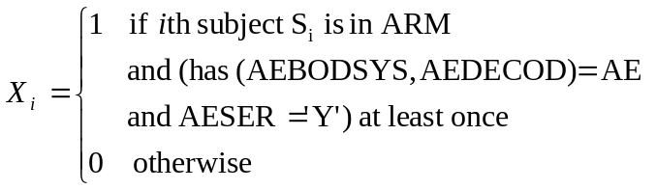  - Note that each subject is counted only once per adverse event, even if they have more than once occurrence of the same adverse event where AESER=‘Y’  - Using dataset DM_EX found in 1.7, find the count of subjects (USUBJID) per arm (ARM)  - The formula for the count of subjects in a given arm is as follows  where  - Using the counts of subjects experiencing each adverse event considered serious per arm found in 3.1 and the counts of subjects per arm found in 3.2, find the percentage of subjects experiencing each adverse event per arm  - The formula for this percentage for a given adverse event AE and arm is as follows  where X and Y are defined as above  - Find counts of subjects experiencing each adverse event across all arms, using the following formula  where ARM_{h} is the hth arm and the inner summation is as defined in 3.1  - Find percentages of subjects experiencing each adverse event across all arms  where ARM_{h} is the hth arm and the inner summations are as defined in 3.1 and 3.2  - Export the results to an Excel spreadsheet listing each adverse event and its counts and percentages by arm  Analysis 3: Adverse Events by Severity and Arm  - This analysis lists how many occurrences of each adverse event there were at each severity/intensity per arm.  - Using dataset AE_DM_EX found in 1.8, find the count of occurrences of each adverse event (AEBODSYS/AEDECOD combination) at each severity/intensity (AESEV) by arm (ACTARM or ARM)  - The formula for the count of occurrences of adverse event AE at severity/intensity SEV in arm ARM is as follows  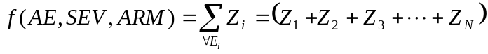  where  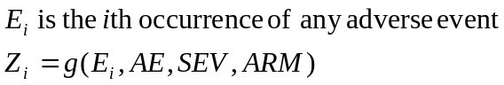  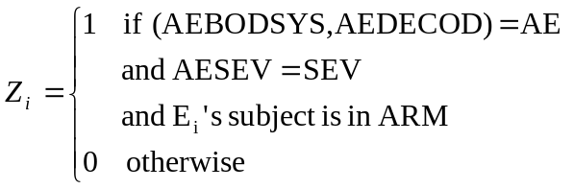  - Find the count of occurrences of each adverse event across all arms and all severity levels, using the following formula  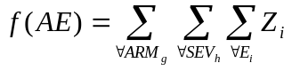  where ARM_{g} is the gth arm, SEV_{h} is the hth severity level, and the inner summation is as defined in 4.1  - Export the results to an Excel spreadsheet listing each adverse event and its counts and percentages by severity/intensity and arm  Analysis 4: Serious Adverse Events by Severity and Arm  - This analysis lists how many serious occurrences of each adverse event there were at each severity/intensity per arm.  - Using dataset AE_DM_EX found in 1.8, find the count of serious occurrences (AESER=‘Y’) of each adverse event (AEBODSYS/AEDECOD combination) at each severity/intensity (AESEV) by arm (ACTARM or ARM)  - The formula for the count of serious occurrences of adverse event AE at severity/intensity SEV in arm ARM is as follows  where  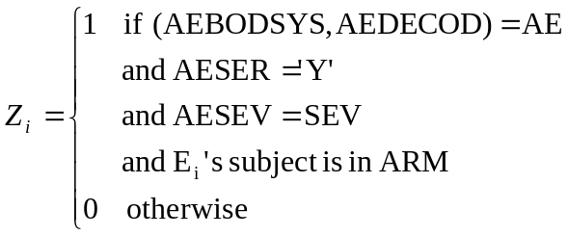  - Find the count of occurrences of each adverse event across all arms and all severity levels, using the following formula  where ARM_{g} is the gth arm, SEV_{h} is the hth severity level, and the inner summation is as defined in 5.1  - Export the results to an Excel spreadsheet listing each adverse event and its counts and percentages by severity/intensity and arm  Analysis: Relative Risk  - This analysis lists the top 30 adverse events by relative risk for each pair of arms along with upper and lower bounds of the 95% confidence interval of relative risk. It also lists how many subjects experienced each adverse event per arm and what percentage of the arm that represents.  - Find the count of subjects experiencing each adverse event (AEBODSYS/AEDECOD combination) by arm (ACTARM or ARM) using the formula in 2.1  - Find the count of subjects (USUBJID) per arm (ACTARM or ARM) using the formula in 2.2  - Using the counts of subjects experiencing each adverse event per arm found in 6.1 and the counts of subjects per arm found in 6.2, find the percentage of subjects experiencing each adverse event per arm using the formula in 2.3  - Using the counts of subjects experiencing each adverse event per arm found in 6.1 and the counts of subjects per arm found in 6.2, create the following 2x2 contingency table to calculate relative risk between each pair of arms in the study  a and c are the counts of subjects who experienced this adverse event in each of arms 1 and 2. b and d are the counts of subjects in arms 1 and 2 that did not experience this adverse event  - Find relative risk of each adverse event between each pair of arms. This is done by the SAS FREQ procedure using the RELRISK option.  - The formula for relative risk of an adverse event between ARM_{j} and ARM_{k} is  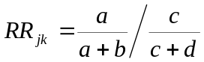  - The user will also be able to choose to add continuity corrections, which handle cases with a zero cell count that would lead to an undefined relative risk statistic.  - The continuity correction is added to each cell in the 2x2 contingency table before calculating relative risk only for those adverse events that have a zero cell count  - The options are No continuity correction, 1 (Laplace’s method), 0.5 (Yates’ method), and the reciprocal of the opposite arm subject count (Sweeting et. al.) This is a panel option that is chosen by the user.  - Find variance and standard error of relative risk. This is done by the SAS FREQ procedure using the RELRISK option.  - Variance of the log of relative risk between ARM_{j} and ARM_{k} is  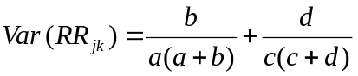  - Standard error of log relative risk between ARM_{j} and ARM_{k} is  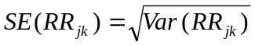  - Find upper and lower bounds of the 95% confidence interval of relative risk between arm ARM_{j} and arm ARM_{k}  - The upper (CIU) and lower (CIL) bounds of the 95% confidence interval of relative risk between ARM_{j} and ARM_{k} are  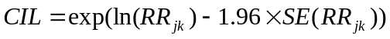  - Sort the adverse events by descending relative risk and keep the top 30  - Export the outputs to an Excel spreadsheet with  - A table for each pair of arms with counts of subjects with each adverse event by arm, percentage of subjects with each adverse event by arm, relative risk of adverse events between the two arms, and upper and lower bounds of the 95% confidence interval around relative risk  - A plot of relative risk and 95% confidence intervals for adverse events in each pair of arms  Analysis: Odds Ratio  - This analysis lists the top 30 adverse events by odds ratio for each pair of arms along with upper and lower bounds of the 95% confidence interval of odds ratio. It also lists how many subjects experienced each adverse event per arm and what percentage of the arm that represents.  - Find the count of subjects experiencing each adverse event (AEBODSYS/AEDECOD combination) by arm (ACTARM or ARM) using the formula in 2.1  - Find the count of subjects (USUBJID) per arm (ACTARM or ARM) using the formula in 2.2  - Using the counts of subjects experiencing each adverse event per arm found in 7.1 and the counts of subjects per arm found in 7.2, find the percentage of subjects experiencing each adverse event per arm using the formula in 2.3  - Using the counts of subjects experiencing each adverse event per arm found in 6.1 and the counts of subjects per arm found in 6.2, create the following 2x2 contingency table to calculate relative risk between each pair of arms in the study  a and c are the counts of subjects who experienced this adverse event in each of arms 1 and 2. b and d are the counts of subjects in arms 1 and 2 that did not experience this adverse event  - Find odds ratio for each adverse event between each pair of arms. This is found by the SAS FREQ procedure using the RELRISK option  - The formula for odds ratio of an adverse event between ARM_{j} and ARM_{k} is  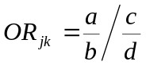  - The user will also be able to choose to add continuity corrections, which handle cases with a zero cell count that would lead to an undefined odds ratio statistic.  - The continuity correction is added to each cell in the 2x2 contingency table before calculating relative risk only for those adverse events that have a zero cell count  - The options are No continuity correction, 1 (Laplace’s method), 0.5 (Yates’ method), and the reciprocal of the opposite arm subject count (Sweeting et. al.) This is a panel option that is chosen by the user.  - Find variance and standard error of odds ratio. This is done by the SAS FREQ procedure using the RELRISK option, which gives asymptotic confidence limits and exact confidence limits are found using the EXACT OR statement  - Asymptotic confidence limits can be computed using the following  - Variance of log odds ratio of an adverse event between ARM_{j} and ARM_{k} is  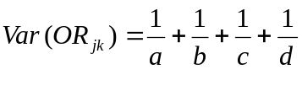  - Standard error of odds ratio of an adverse event between ARM_{j} and ARM_{k} is  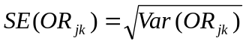  - Find upper and lower bounds of the 95% confidence interval of odds ratio of an adverse event between arm ARM_{j} and arm ARM_{k}  - The upper (CIU) and lower (CIL) bounds of the 95% confidence interval of odds ratio of an adverse event between ARM_{j} and ARM_{k} are  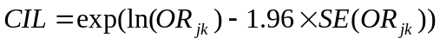  - Use exact confidence limits whenever they are available, namely when using no continuity correction or using Laplace’s method (1), otherwise use asymptotic confidence limits  - Sort the adverse events by descending odds ratio and keep the top 30  - Export the outputs to an Excel spreadsheet with  - A table for each pair of arms with counts of subjects with each adverse event by arm, percentage of subjects with each adverse event by arm, odds ratio of adverse events between the two arms, and upper and lower bounds of the 95% confidence interval around odds ratio  - A plot of odds ratio and 95% confidence intervals for adverse events in each pair of arms
   | Arm 1 | Arm 2
  Adverse event | a | c
  No adverse event | b | d
   | Arm 1 | Arm 2
  Adverse event | a | c
  No adverse event | b | d
Screenshots | Analysis 1: Adverse Events by Arm Greater than 2%  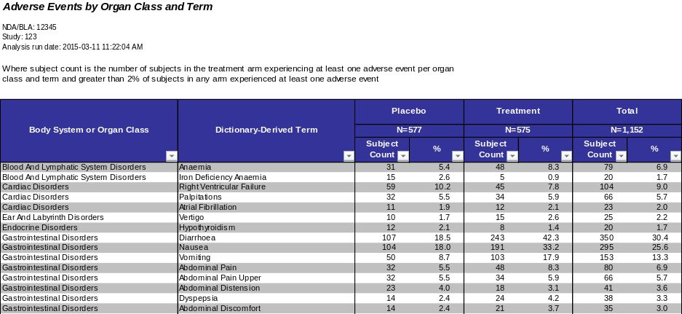  Analysis 2: Serious Adverse Events by Arm  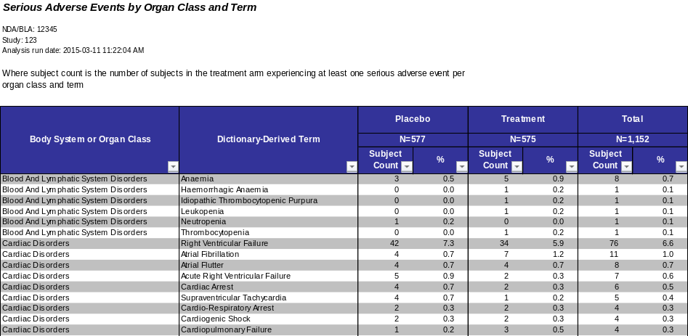  Analysis 3: Adverse Events by Severity and Arm  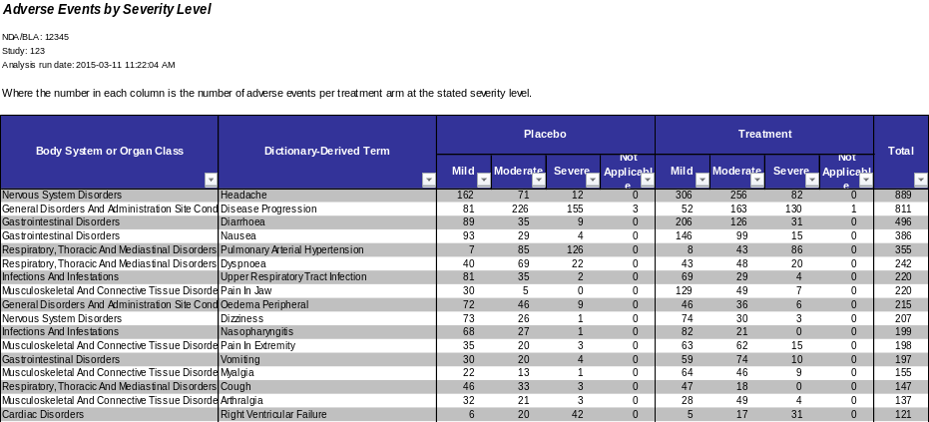  Analysis 4: Serious Adverse Events by Severity and Arm  Analysis: Relative Risk  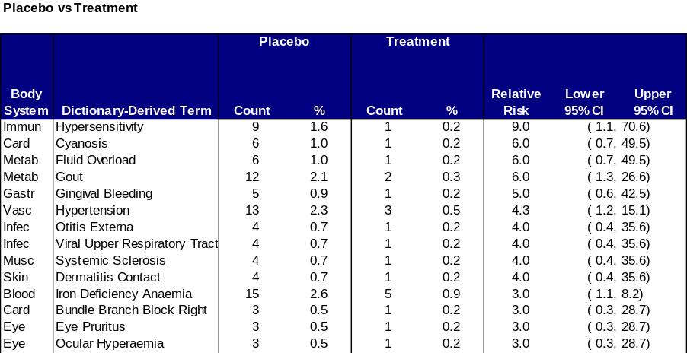  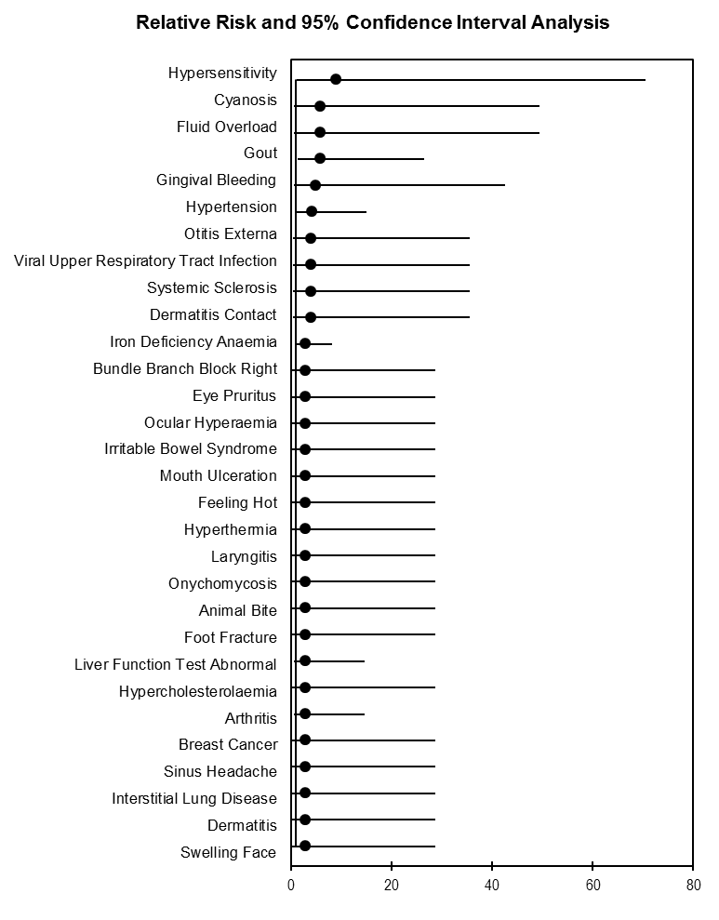  Analysis: Odds Ratio  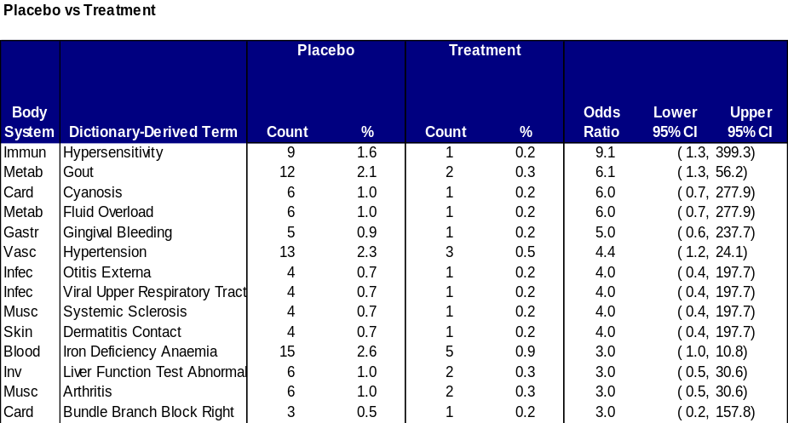  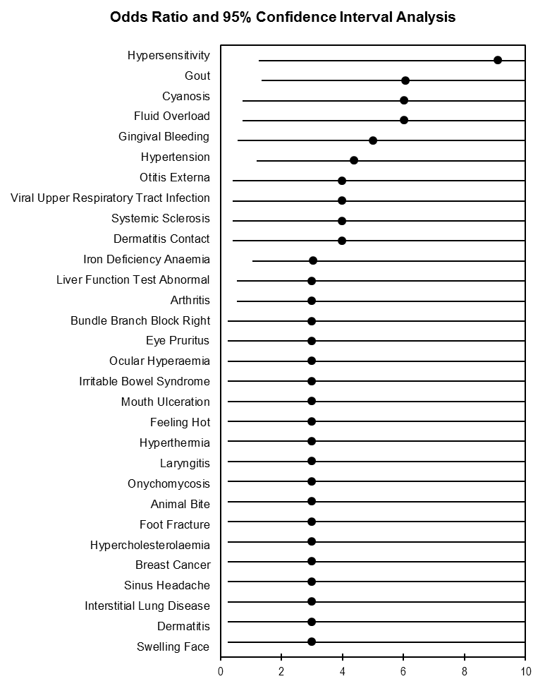
Output to: | One Excel workbook for the counts and percentages per arm and per severity level and arm. One Excel workbook each for the relative risk and odds ratio analyses.
Data Checks | - Keep counts and percentages of subjects excluded in total and per arm for the following reasons  - Not assigned or screen failure – ARMCD in (‘SCRNFAIL’,’NOTASSGN’)  - Not in the safety population – not in EX  - No treatment start and end dates  - Keep counts and percentages of adverse events excluded per arm for the following reasons  - The adverse event start date was missing or could not be decoded into a date containing at least month and year  - The adverse event start date was outside the subject’s treatment period + user-defined number of days following the end of treatment  - The body system or organ class (AEBODSYS) or dictionary-derived term (AEDECOD) was missing  - Keep counts and percentages of subject’s adverse events that were included in the analysis were missing severity levels per arm
Assumptions: | The Adverse Event Analysis Panel assumes:  - The user has access to CDISC SDTM datasets such as the Demographic (DM) Adverse Event (AE), and Exposure (EX) datasets.  - The analysis can only be used to examine treatment sequences in cross-over studies and not individual treatments  - The user has a basic understanding of the statistical significance behind the Relative Risk and Odds Ratio calculations and understand continuity correction factors.
Notes and Issues: | Limitations:  - If ACTARM is not available, the panel defaults to using planned treatment arm (ARM) as there is no way to automatically determine the actual treatment arm otherwise  - The panel currently relies on subject’s reference start and end date in the demographics domain, or on their first and last exposure events in the exposure domain, rather than on dates explicitly stating when participation or treatment started or ended
Approval /  Validation Status | Status Pending and Validation Required.
Created By: | Juan Cruz Lema-Heyl
Date Created: | 02/26/2010 | Last Updated By: | David Kretch

Appendix

SAS Source Code
/****************************************************************************/
/* PROGRAM NAME: Adverse Events Panel */
/* */
/* DESCRIPTION: Find subject counts per arm for each adverse event */
/* Find event counts per arm and severity level for */
/* each adverse event */
/* Find top adverse events by relative risk & */
/* odds ratio between each pair of arms */
/* Creates three output files: */
/* Adverse events counts analysis */
/* Odds ratio analysis */
/* Relative risk analysis */
/* */
/* EVALUATION TYPE: Safety */
/* */
/* AUTHOR: David Kretch (david.kretch@us.ibm.com) */
/* Andreas Anastassopoulos */
/* (andreas.anastassapoulos@us.ibm.com) */
/* */
/* DATE: February 7, 2011 */
/* */
/* EXTERNAL FILES USED: ae_setup.sas -- Merges AE, DM, and EX */
/* ae_aggregate.sas -- Finds the subject/event counts */
/* ae_output.sas -- Creates the Excel XML output */
/* ae_xml_output.sas -- XML formatting macros */
/* data_checks.sas -- Generic variable checks */
/* sl_output.sas -- Script Launcher settings output */
/* ae_rror.sas -- Relative risk/odds ratio analysis */
/* ae_or_template.xls -- Odds ratio Excel template */
/* ae_rr_template.xls -- Relative risk Excel template */
/* */
/* PARAMETERS REQUIRED: outpath -- location of the output */
/* saspath -- location of the external SAS programs */
/* studypath -- location of the drug study datasets */
/* templatepath -- location of the Excel templates */
/* oroutfile -- filename of OR output */
/* rroutfile -- filename of RR output */
/* */
/* study_lag -- window in days after last exposure */
/* where AEs should be kept in analysis */
/* cc -- continuity correction value */
/* */
/* VARIABLES REQUIRED: AE -- AEBODSYS */
/* AEDECOD */
/* USUBJID */
/* DM -- ARM */
/* USUBJID */
/* EX -- USUBJID */
/* */
/* VARIABLES USED: AE -- AESTDTC */
/* WHEN AVAILABLE AESER */
/* AESEV */
/* DM -- RFSTDTC */
/* RFENDTC */
/* ARMCD */
/* EX -- EXSTDTC */
/* EXENDTC */
/* */
/* MADE WITH: SAS 9.2 */
/* */
/* NOTES: */
/* */
/* REVISIONS: --- */
/* */
/****************************************************************************/

/* delete all datasets and user macro variables */
proc datasets kill; quit;
data macrovar; set sashelp.vmacro(keep=scope name where=(scope='GLOBAL')); run;
data _null_; set macrovar; call execute('%symdel '||trim(left(name))||';'); run;
proc datasets library=work memtype=data nolist nodetails; delete macrovar; quit;

/* the minoperator option allows the use of the in operator by the macro language */
options minoperator;
options missing='';

%let saspath = C:\ScriptLauncher\AE;

%let outpath = C:\ ScriptLauncher\AE;

%let studypath = C:\ ScriptLauncher\AE;

libname inlib "&studypath.";

/* NDA/BLA and study number */
%let ndabla = 12345;
%let studyid = 123;

/* data validation switch; determines whether to perform data validation on AEs */
%let vld_sw = 1;

/* study lag in days; determines window in days following the end of a study */
/* in which AEs should be included in the analysis */
%let study_lag = 45;

/*****************************************/
/* ODDS RATIO / RELATIVE RISK PARAMETERS */
/*****************************************/
%let templatepath = C:\ScriptLauncher\AE;
%let rr_template = ae_rr_template.xls;
%let or_template = ae_or_template.xls;

%let rroutfile = ae_rr_output.xls;
%let oroutfile = ae_or_output.xls;

/* continuity correction method */
/* arm adds the reciprocal of the opposite arm */
/* otherwise any number is added as a constant */
%let cc = 0;

/* set the continuity correction & whole number switch/indicator */
data _null_;
if anyalpha("&cc.") then cc = "&cc.";
else cc = &cc.;

if anyalpha(cc) and cc = 'arm' then cc_sw = 2;
else if not missing(cc) and cc ne 0 then cc_sw = 1;
else cc_sw = 0;

if cc_sw = 2 then cc_whole = 0;
else if (cc - floor(cc) ne 0) then cc_whole = 0;
else cc_whole = 1;

call symputx('cc_sw',cc_sw,'g');
call symputx('cc_whole',cc_whole,'g');
run;

/****************************************************/
/* checks whether variable VAR exists in dataset DS */
/* and sets macro variable DS_VAR as follows */
/* DS_VAR = 1 if VAR exists */
/* DS_VAR = 0 if VAR does not exist */
/* also inserts a record into RPT_CHK_VAR */
/* */
/* sets DS_VAR_TYPE to variable type */
/****************************************************/
%macro chk_var(lib=work,ds=,var=);

%global &ds._&var.;

data chk_var_&ds._&var.;
length chk $12 ds $32 var $36 type $1 len 8. condition $200 ind 8.;
chk = 'VAR';
ds = upcase("&ds.");
var = upcase("&var.");
condition = 'EXISTS';

dsid = open("&lib..&ds.");
if dsid then do;
ind = ifn(varnum(dsid,upcase("&var."))>0,1,0);
if ind then do;
type = vartype(dsid,varnum(dsid,upcase("&var.")));
len = varlen(dsid,varnum(dsid,upcase("&var.")));
end;
else do;
type = '';
len = -1;
end;
rc = close(dsid);
drop rc;
end;
else do;
ind = 0;
type = '';
len = -1;
end;

drop dsid;

call symputx("&ds._&var.",ind,'g');
call symputx("&ds._&var._type",type,'g');
call symputx("&ds._&var._len",len,'g');
run;

data rpt_chk_var;
merge %if %sysfunc(exist(rpt_chk_var)) %then rpt_chk_var; chk_var_&ds._&var.;
by ds var;
run;

proc datasets library=work nolist nodetails; delete chk_var_&ds._&var.; quit;

%mend chk_var;

/****************************************************************************/
/* checks whether dataset DS has values VAL1-VAL15 in variable VAR */
/* and sets macro variable DS_VAR_VAL as follows: */
/* DS_VAR_VAL = 1 if VAL is present */
/* DS_VAR_VAL = 0 if VAL is not present */
/* DS_VAR_VAL = -1 if DS does not exist or VAR does not exist */
/* */
/* the macro will also insert a record into RPT_CHK_VAL for each value */
/* with the appropriate indicator depending upon the presence or absence of */
/* the value in variable VAR */
/* */
/* argument CS makes the macro use case sensitive variable values */
/* argument COUNT makes the macro find counts instead of indicators */
/* */
/* tbd: macro variable DS_VAR_MISSING, */
/* macro will fail if DS_VAR_VAL is too long */
/****************************************************************************/
%macro chk_val(lib,ds,var,
val1, val2, val3, val4, val5,
val6, val7, val8, val9, val10,
val11,val12,val13,val14,val15,
cs=F,count=F);

%let cs = %upcase(&cs.); %let count = %upcase(&count.);

/* find the number of values to look up */
%let i = 1;
%do %while (%symexist(val&i.));
%if (&&&val&i. = ) %then %goto max_arg;
%let i = %eval(&i. + 1);
%end;
%max_arg: %let max_arg = %eval(&i. - 1);

%if %symexist(vals) %then %symdel vals;

/* get the data type and length of VAR */
%let dsid = %sysfunc(open(&lib..&ds.));
%if &dsid. > 0 %then %do;
%let varnum = %sysfunc(varnum(&dsid.,&var.));
%if &varnum. > 0 %then %do;
%let type = %sysfunc(vartype(&dsid.,&varnum.));
%let len = %sysfunc(varlen(&dsid.,&varnum.));
%end;
%let rc = %sysfunc(close(&dsid.));
%end;

/* if the macro was able to determine the length and type of the variable */
/* then set a success code. otherwise, set a failure code and go to the end */
%if %symexist(type) and %symexist(len) %then %let success = 1;
%else %do;
%let success = 0;
%let type = C;
%let len = 200;
%end;

/* look for missing keyword and replace with missing */
%do i = 1 %to &max_arg.;
%if %upcase(&&&val&i.) = &miss. %then %let val&i. = %sysfunc(ifc(&type.=C,,.));
%end;

/* create the list of values to look up */
data _null_;
vals = %do i = 1 %to &max_arg.;
ifc("&type." = 'C',"%str(%')&&&val&i.%str(%')","&&&val&i.")||
ifc("&i." ne "&max_arg.",',','')||
%end;
'';
if "&cs." ne 'T' then vals=upcase(vals);

call symputx('vals',vals);
run;

/* create a dummy dataset for joining */
data dual; call missing(dummy); run;

/* a list of all values sought */
/* counts of those appearing in the dataset will be joined to these */
/* those not appearing in the dataset will get an appropriate indicator */
data chk_val_&ds._&var._val;
length &var. %sysfunc(ifc(&type.=C,$,))&len.;
%do i = 1 %to &max_arg.;
&var. = ifc("&cs." ne 'T',upcase("&&&val&i."),"&&&val&i."); output;
%end;
run;

proc sql noprint;
create table chk_val_&ds._&var. as
select "VAL" length=12 as chk,
upcase("&ds.") length=32 as ds,
upcase("&var.") length=36 as var,
%sysfunc(ifc(&type.=C,a.&var.,put(a.&var.,8.7 -L))) length=200 as val,
%if &count. ne T %then %do;
"PRESENT" length=200 as condition,
(case
when count > 0 then 1
when count = -1 then -1
else 0
end) as ind
%end;
%else %do;
"COUNT" length=200 as condition,
(case when count is not missing then count else 0 end) as ind
%end;
from chk_val_&ds._&var._val a

/* if the variable exists, find the counts of the requested values */
%if &success. %then %do;
left join (select &var., count(1) as count
from &lib..&ds.
where %sysfunc(ifc(&type.=C and &cs. ne T,upcase(&var.),&var.)) in (&vals.)
group by &var.) b
on a.&var. = b.&var.
%end;

/* else set all indicators to -1 */
%else %do;
left join (select -1 as count
from dual) b
on 1=1
%end;
;
quit;

/* set missing values to 'MISSING' */
data chk_val_&ds._&var.;
set chk_val_&ds._&var.;
if "&type." = 'C' and val = ''
or "&type." = 'N' and val in ('','.')
then val = 'MISSING';
run;

proc sort data=chk_val_&ds._&var.; by ds var val condition; run;

data rpt_chk_val;
merge %if %sysfunc(exist(rpt_chk_val)) %then rpt_chk_val; chk_val_&ds._&var.(in=a);
by ds var val condition;
if a then call symputx(compress(ds)||'_'||compress(var)||'_'||
compress(translate(trim(val),'_',' '),'_','ak')||
ifc("&count."='T','_cnt',''),ind,'g');
run;

proc datasets library=work nolist nodetails; delete chk_val_&ds._&var.: dual; quit;

/* if dataset DS or variable VAR do not exist, then print an error */
%if not &success. %then %do;
%put ERROR: Dataset &ds. or variable &var. does not exist;
%end;

%mend chk_val;

/* sets up datasets for aggregation */
/* finds safety population and adverse events during study */
%macro setup(mdhier=N,dme=N);

/* if data validation switch doesn't exist, set it to on */
%if not %symexist(vld_sw) %then %let vld_sw = 1;

/* if there is no study lag defined, set it to 30 days */
%if not %symexist(study_lag) %then %let study_lag = 30;

/* retrieve the required datasets */
data ae; set inlib.ae; run;
data dm; set inlib.dm; run;
data ex; set inlib.ex; run;

/**************************/
/* preliminary datachecks */
/**************************/

%log_msg(DATA CHECKS);

/* required variables */
%chk_var(ds=ae,var=aebodsys);
%chk_var(ds=ae,var=aedecod);
%chk_var(ds=ae,var=usubjid);
%chk_var(ds=dm,var=arm);
%chk_var(ds=dm,var=usubjid);
%chk_var(ds=ex,var=usubjid);

/* set a flag indicating whether all required variables are present */
%global setup_req_var;
%if &ae_aebodsys.
and &ae_aedecod.
and &ae_usubjid.
and &dm_arm.
and &dm_usubjid.
and &ex_usubjid. %then %let setup_req_var = 1;
%else %let setup_req_var = 0;

%if not &setup_req_var. %then %goto setup_exit;

/* optional variables */
%chk_var(ds=ae,var=aestdtc);
%chk_var(ds=ae,var=aeser);
%chk_var(ds=ae,var=aesev);
%chk_var(ds=ae,var=aetoxgr);
%chk_var(ds=dm,var=rfstdtc);
%chk_var(ds=dm,var=rfendtc);
%chk_var(ds=dm,var=armcd);
%chk_var(ds=ex,var=exstdtc);
%chk_var(ds=ex,var=exendtc);

%let ex_exdtc = %sysfunc(ifc(&ex_exstdtc. and &ex_exendtc.,1,0));
%let dm_rfdtc = %sysfunc(ifc(&dm_rfstdtc. and &dm_rfendtc.,1,0));

/* if no dates are available, turn off the AE validation */
%if not (&ae_aestdtc. and (&ex_exdtc. or &dm_rfdtc.)) %then %do;
%let vld_sw = 0;
%put;
%put WARNING: AE data validation has been turned off because required variables are missing;
%put;
%end;

/***********************************/
/* subjects from demographics (DM) */
/***********************************/

%log_msg(%str(DEMOGRAPHICS DOMAIN (DM)));

data all_dm;
set dm(keep=arm usubjid
%if &dm_armcd. %then armcd;
%if &vld_sw. and &dm_rfdtc. %then rfstdtc rfendtc;
);

/* exclude screen failures and unassigned subjects */
%if &dm_armcd. %then %do;
if armcd in ('SCRNFAIL' 'NOTASSGN') then delete;
%end;

%if &vld_sw. and &dm_rfdtc. %then %do;
length rfstdt 8. rfendt 8.;
format rfstdt e8601da. rfendt e8601da.;
label rfstdt='Subject Reference Start Date' rfendt='Subject Reference End Date';
call missing(rfstdt,rfendt);

/* depending on the minimum date length, extract either year/month/day or year/month */
/* store the min. date length for future use */
min_rfdt_len = min(length(trim(rfstdtc)),length(trim(rfendtc)));

if min_rfdt_len >= 10 then do;
if not missing(rfstdtc) then rfstdt = input(substr(rfstdtc,1,10),e8601da.);
if not missing(rfendtc) then rfendt = input(substr(rfendtc,1,10),e8601da.);
end;
else if min_rfdt_len >= 7 then do;
if not missing(rfstdtc)
then rfstdt = mdy(input(substr(rfstdtc,6,2),2.),1,input(substr(rfstdtc,1,4),4.));
if not missing(rfendtc)
then rfendt = mdy(input(substr(rfendtc,6,2),2.),1,input(substr(rfendtc,1,4),4.));
end;
%end;
run;

proc sort data=all_dm; by usubjid; run;

/****************************************/
/* safety population from exposure (EX) */
/****************************************/

%log_msg(%str(EXPOSURE DOMAIN (EX)));

proc sort data=ex; by usubjid;

data all_ex;
set ex(keep=usubjid %if &vld_sw. and &ex_exdtc. %then exstdtc exendtc;);
by usubjid;

%if &vld_sw. and &ex_exdtc. %then %do;
retain exstdt exendt exstdtc_r exendtc_r;
length exstdt 8. exendt 8.;
format exstdt e8601da. exendt e8601da.;
label exstdt='Treatment Start Date' exendt='Treatment End Date';

/* convert the character treatment start date/time to numeric */
if not missing(exstdtc) and length(trim(exstdtc)) >= 10
then exstdtn = input(substr(exstdtc,1,10),e8601da.);
if not missing(exendtc) and length(trim(exendtc)) >= 10
then exendtn = input(substr(exendtc,1,10),e8601da.);

/* find the minimum treatment start date and maximum treatment end date */
if first.usubjid then do;
exstdt = exstdtn;
exendt = exendtn;
exstdtc_r = exstdtc;
exendtc_r = exendtc;
end;
else do;
/* if the first treatment start date is missing, set the min. treatment start date */
/* to the next nonmissing treatment start date */
if missing(exstdt) and not missing(exstdtn) then do;
exstdt = exstdtn;
exstdtc_r = exstdtc;
end;
else if not missing(exstdtn) and exstdtn < exstdt then do;
exstdt = exstdtn;
exstdtc_r = exstdtc;
end;

if exendtn > exendt then do;
exendt = exendtn;
exendtc_r = exendtc;
end;
end;

min_exdt_len = 10;

drop exstdtn exendtn exstdtc exendtc;
rename exstdtc_r=exstdtc
exendtc_r=exendtc;
%end;

if last.usubjid then output;
run;

/**********************************************************/
/* all subjects in the safety population assigned to arms */
/**********************************************************/

%log_msg(%str(SUBJECTS IN SAFETY POPULATION (DM & EX)));

data all_dm_ex(keep=arm usubjid %if &vld_sw. %then trtstdt trtendt trtdt_len;)
err_dm_ex;
merge all_dm(in=a)
all_ex(in=b);
by usubjid;

/* if the subject is in both DM and EX, then output */
if a and b then output = 1;
else if a then do;;
output = 0;
err_type = 'ex';
end;
else delete;

%if &vld_sw. %then %do;
if output then do;
format trtstdt e8601da. trtendt e8601da.;
label trtstdt='Subject Treatment Start Date' trtendt='Subject Treatment End Date';
call missing(trtstdt,trtendt);

%if &ex_exdtc. %then %do;
if not missing(exstdt) and not missing(exendt) then do;
trtstdt = exstdt;
trtendt = exendt;
trtdt_len = min_exdt_len;
end;
%end;
%if &dm_rfdtc. %then %do;
if not missing(rfstdt) and not missing(rfendt) and missing(trtstdt) and missing(trtendt) then do;
trtstdt = rfstdt;
trtendt = rfendt;
trtdt_len = min_rfdt_len;
end;
%end;

/* if the subject does not have valid start and end dates, then do not output */
if missing(trtstdt) or missing(trtendt) then do;
output = 0;
err_type = 'dt';
end;
end;
%end;

if output then output all_dm_ex;
else output err_dm_ex;
run;

/* get counts of subjects per arm */
proc sql noprint;
create table all_arm as
select arm, count(distinct usubjid) as count
from all_dm_ex
group by arm
order by arm;

/* get maximum arm name length */
%global max_arm_nm_len;
select max(length(arm)) into: max_arm_nm_len
from all_arm;
quit;

data all_arm;
set all_arm end=eof;

arm_num = _n_;

retain total;
total = sum(total,count);

call symputx('arm_'||put(_n_,8. -L),put(count,8. -L),'g');

if eof then do;
call symputx('arm_count',put(_n_,8. -L),'g');
call symputx('arm_total',put(total,8. -L),'g');
end;
run;

/* assign arm numbers */
data all_dm_ex;
set all_dm_ex;

if _n_ = 1 then do;
declare hash h(dataset:'all_arm');
h.definekey('arm');
h.definedata('arm_num');
h.definedone();
end;

length arm_num 8.;
label arm_num='Arm Number';
call missing(arm_num);
rc = h.find();
drop rc;
run;

/**************************************/
/* import adverse events (AE) dataset */
/**************************************/

%log_msg(%str(ADVERSE EVENTS DOMAIN (AE)));

data all_ae;
retain usubjid aebodsys aedecod;
set ae(keep=usubjid aebodsys aedecod
%if &ae_aeser. %then aeser;
%if &ae_aesev. %then aesev;
%if &ae_aetoxgr. %then aetoxgr;
%if &vld_sw. %then aestdtc;
);

/* change adverse event descriptions variables to proper noun case */
if not anylower(aebodsys) then aebodsys = propcase(aebodsys);
if not anylower(aedecod) then aedecod = propcase(aedecod);

/* validate AETOXGR */
%if &ae_aetoxgr. %then %do;
%if %symexist(toxgr_min) and %symexist(toxgr_max) %then %do;
/* convert from character to numeric if necessary */
%if &ae_aetoxgr_type. = C %then %do;
if not notdigit(aetoxgr) then aetoxgr_num = input(aetoxgr,8.);
%end;
%else %do;
aetoxgr_num = aetoxgr;
%end;

if not (&toxgr_min. <= aetoxgr_num <= &toxgr_max.) then aetoxgr_num = .;
drop aetoxgr;
rename aetoxgr_num = aetoxgr;
%end;
%end;
%else %do;
call missing(aetoxgr);
%end;

/* convert the character start date/time of the AE to numeric */
%if &vld_sw. %then %do;
format aestdt e8601da.;
label aestdt='Adverse Event Start Date';
call missing(aestdt);

aedt_len = length(trim(aestdtc));

if aedt_len >= 10 then aestdt = input(substr(aestdtc,1,10),e8601da.);
else if aedt_len >= 7
then aestdt = mdy(input(substr(aestdtc,6,2),2.),1,input(substr(aestdtc,1,4),4.));
%end;
run;

proc sort data=all_ae; by usubjid aebodsys aedecod; run;

/******************************************************/
/* find all adverse events whose subject */
/* is assigned to an arm and in the safety population */
/******************************************************/

%log_msg(%str(ADVERSE EVENTS FOR SUBJECTS IN SAFETY POPULATION (AE, DM, & EX)));

data all_ae_dm_ex;
merge all_dm_ex(in=a)
all_ae(in=b)
;
by usubjid;
if a and b;
run;

/* keep only those adverse events that took place during the study analysis period */
/* keep counts of adverse events included and excluded in a reporting dataset */
data ds_base(drop=err: %if &vld_sw. %then aedt: aestdt: stdt endt trtdt: trtstdt: trtendt: dt_len;)
err_base(drop=total);
set all_ae_dm_ex end=eof;

total = 'Total'; /* for aggregating over all adverse events */

length err 8 err_type $10 err_desc $50;
call missing(err,err_type,err_desc);

/* do data validation if data validation switch is on */
%if &vld_sw. = 1 %then %do;
/* find the minimum length date length for the AE start date and treatment start and end dates */
/* this is the most date/time information that can be compared */
dt_len = min(aedt_len,trtdt_len);

format aedt e8601da. stdt e8601da. endt e8601da.;

if dt_len >= 10 then do;
aedt = aestdt;
stdt = trtstdt;
endt = trtendt;
end;
else if dt_len >= 7 then do;
aedt = mdy(input(substr(put(aestdt,e8601da.),6,2),2.),1,input(substr(put(aestdt,e8601da.),1,4),4.));
stdt = mdy(input(substr(put(trtstdt,e8601da.),6,2),2.),1,input(substr(put(trtstdt,e8601da.),1,4),4.));
endt = mdy(input(substr(put(trtendt,e8601da.),6,2),2.),1,input(substr(put(trtendt,e8601da.),1,4),4.));
end;

/* flag adverse events within study period for output */
/* flag those outside as errors */
if dt_len >= 7 then do;
if stdt <= aestdt <= intnx(ifc(dt_len>=10,'day','month'),
endt,
ifn(dt_len>=10,&study_lag.,floor(&study_lag./30)))
then output = 1;
else do;
output = 0;
err_type = 'dt';
err = 2; err_desc = '2. Date outside study analysis period';
end;
end;
else do;
output = 0;
err_type = 'dt';
err = 1; err_desc = '1. Date missing or incomplete';
end;

/* flag records with missing AEBODSYS or AEDECOD descriptions */
if aebodsys = '' or aedecod = '' then do;
output = 0;
err_type = 'desc';
err = 3; err_desc = '3. Description missing';
end;
%end;
%else %do;
output = 1;
%end;

if output then output ds_base;
else output err_base;
run;

proc sort data=ds_base; by aebodsys aedecod; run;

/****************************************/
/* MEDDRA AND DESIGNATED MEDICAL EVENTS */
/****************************************/

%if &mdhier. = Y %then %do;

%log_msg(LOOK UP MEDDRA TERMS);

/* merge by-subject/preferred term adverse events with */
/* the appropriate version of the MedDRA hierarchy */
data ds_base_meddra(drop=aebodsys aedecod)
err_base_meddra;
set ds_base(drop=output);

aebodsys = upcase(aebodsys);
aedecod = upcase(aedecod);

if _n_ = 1 then do;
declare hash h(dataset:"meddra.mdhier_%sysfunc(translate(&ver.,'_','.'))");
h.definekey('aebodsys','aedecod');
h.definedata('soc_name','hlgt_name','hlt_name','pt_name');
h.definedone();
end;

length soc_name $100 hlgt_name $100 hlt_name $100 pt_name $100;
label soc_name='System Organ Class'
hlgt_name='High-Level Group Term'
hlt_name='High-Level Term'
pt_name='Preferred Term';
call missing(soc_name,hlgt_name,hlt_name,pt_name);

rc = h.find();
if rc = 0 then output = 1;
else output = 0;
drop rc;

/* add designated medical event flag */
%if &dme. = Y %then %do;
if _n_ = 1 then do;
declare hash i(dataset:'dme.dme_pt');
i.definekey('soc_name','hlgt_name','hlt_name','pt_name');
i.definedata('dme');
i.definedone();
end;

length dme $1;
label dme='Designated Medical Event';
call missing(dme);

rc = i.find();
drop rc;
%end;

if output then output ds_base_meddra;
else output err_base_meddra;
run;

/* MedDRA matching report */
/* get the counts of each term without a matching MedDRA description and number of subjects affected */
proc sql noprint;
/* store count and proportion of adverse events that were matched with MedDRA terms */
create table rpt_meddra as
select "MedDRA hierarchy version &ver." as meddra_ver,
meddra_cnt,
err_cnt,
100*meddra_cnt/(meddra_cnt+err_cnt) as meddra_pct
from (select count(1) as meddra_cnt from ds_base_meddra),
(select count(1) as err_cnt from err_base_meddra);

%global meddra_pct meddra;
select meddra_pct,
case when meddra_pct >= 80 then 'Y' else 'N' end
into : meddra_pct, : meddra
from rpt_meddra;

create table rpt_meddra_term as
select (case when a.aebodsys is missing then b.aebodsys else a.aebodsys end) as aebodsys
label='Body System or Organ Class',
(case when a.aedecod is missing then b.aedecod else a.aedecod end) as aedecod
label='Dictionary-Derived Term',
subj_count, event_count
from (select aebodsys, aedecod, count(distinct usubjid) as subj_count label='No Matching MedDRA Description Subject Count'
from err_base_meddra
group by aebodsys, aedecod) a,
(select aebodsys, aedecod, count(1) as event_count label='No Matching MedDRA Description Event Count'
from err_base_meddra
group by aebodsys, aedecod) b
where a.aebodsys = b.aebodsys
and a.aedecod = b.aedecod;
quit;

data rpt_meddra_term;
set rpt_meddra_term;
aebodsys = propcase(aebodsys);
aedecod = propcase(aedecod);
run;

%end;

/* write out arms into macro variables in propcase form */
data all_arm;
set all_arm end=eof;

/* put words into propcase, leave acronyms and abbreviations as-is */
arm_display = arm;
if arm_display ne '' and not anylower(arm_display) then do;
length arm_word $50;
i = 1;
arm_word = scan(arm_display,i);
do while (arm_word ne '');
if length(arm_word) > 3 and not anydigit(compress(arm_word))
then substr(arm_display,index(arm_display,compress(arm_word)),length(compress(arm_word))) = propcase(compress(arm_word));
if compress(arm_word) in ('MG' 'KG')
then substr(arm_display,index(arm_display,compress(arm_word)),length(compress(arm_word))) = lowcase(arm_word);
if compress(arm_word) = ('ML')
then substr(arm_display,index(arm_display,compress(arm_word)),length(compress(arm_word))) = 'mL';
i = i + 1;
arm_word = scan(arm_display,i);
end;
end;

call symputx('arm_name_'||put(_n_,8. -L),arm_display,'g');

drop arm_word i;
run;

/* create setup reporting datasets */
%rpt_setup;

%setup_exit: %global setup_success;
%if not &setup_req_var. %then %do;
%put ERROR: Some variables required for AE setup are missing;
%let setup_success = 0;
%end;
%else %let setup_success = 1;

%mend setup;

/* reporting info on data validation and MedDRA matching */
%macro rpt_setup;

/* DEMOGRAPHICS */
/* subject validation */

%log_msg(SUBJECT VALIDATION REPORT);

/* get counts of the subjects removed before arriving at the set of subjects */
/* used in the analysis */
proc sql;
create table rpt_dm(drop=order) as

/* Subjects in demographics (DM) */
select 1 as order, '1. Subjects in demographics (DM)' as desc,
%do i = 1 %to &arm_count.;
sum(case when upcase(arm) = upcase("&&&arm_name_&i.") then 1 else 0 end) as arm&i._count,
%end;
count(1) as total_count
from dm

union

/* Subjects removed - unassigned/screen failure */
select 2 as order, '2. Subjects removed - unassigned/screen failure' as desc,
%if &dm_armcd. %then %do;
%do i = 1 %to &arm_count.;
sum(case
when upcase(arm) = upcase("&&&arm_name_&i.") and armcd in ('SCRNFAIL','NOTASSGN')
then 1
else 0
end) as arm&i._count,
%end;
sum(case when armcd in ('SCRNFAIL','NOTASSGN')then 1 else 0 end) as total_count
%end;
%else %do;
%do i = 1 %to &arm_count.;
0 as arm&i._count,
%end;
0 as total_count
%end;
from dm

union

/* Subjects removed - not in safety population */
select 3 as order, '3. Subjects removed - not in safety population' as desc,
%do i = 1 %to &arm_count.;
(case when arm&i._count is missing then 0 else arm&i._count end) as arm&i._count,
%end;
total_count
from (select %do i = 1 %to &arm_count.;
sum(case when upcase(arm) = upcase("&&&arm_name_&i.") then 1 else 0 end) as arm&i._count,
%end;
count(1) as total_count
from err_dm_ex
where err_type = 'ex')

union

/* Subjects removed - no treatment/reference dates */
select 4 as order, '4. Subjects removed - no treatment/reference dates' as desc,
%do i = 1 %to &arm_count.;
(case when arm&i._count is missing then 0 else arm&i._count end) as arm&i._count,
%end;
total_count
from (select %do i = 1 %to &arm_count.;
sum(case when upcase(arm) = upcase("&&&arm_name_&i.") then 1 else 0 end) as arm&i._count,
%end;
count(1) as total_count
from err_dm_ex
where err_type = 'dt')

union

/* Subjects used in analysis */
select 5 as order, '5. Subjects used in analysis' as desc,
%do i = 1 %to &arm_count.;
sum(case when upcase(arm) = upcase("&&&arm_name_&i.") then 1 else 0 end) as arm&i._count,
%end;
count(1) as total_count
from all_dm_ex;
quit;

/* add percentages of the original arm subject counts */
data rpt_dm;
retain desc %do i = 1 %to &arm_count.; arm&i._count arm&i._pct %end;;
set rpt_dm;

%do i = 1 %to &arm_count.;
retain dm_arm&i._count;
if _n_ = 1 then dm_arm&i._count = arm&i._count;
arm&i._pct = 100*arm&i._count/dm_arm&i._count;
drop dm_arm&i._count;
%end;

retain dm_total_count;
if _n_ = 1 then dm_total_count = total_count;
total_pct = 100*total_count/dm_total_count;
drop dm_total_count;
run;

/* ADVERSE EVENTS */

%log_msg(ADVERSE EVENT DATA VALIDATION REPORT);

/* write out number of adverse events in safety population */
%global naes_sp;
%let dsid = %sysfunc(open(all_ae_dm_ex));
%let naes_sp = %sysfunc(attrn(&dsid.,nobs));
%let rc = %sysfunc(close(&dsid.));

/* and for each arm */
%do i = 1 %to &arm_count.; %global naes_sp_&i.; %end;;
proc sql noprint;
select count(1) into : naes_sp_1 - : naes_sp_&arm_count.
from all_ae_dm_ex
group by arm_num;
quit;

/* write out number of validated adverse events in safety population */
%global naes_spv;
%let dsid = %sysfunc(open(ds_base));
%let naes_spv = %sysfunc(attrn(&dsid.,nobs));
%let rc = %sysfunc(close(&dsid.));

/* create table of counts of each kind of error (e.g. invalid dates) */
proc sql noprint;
create table rpt_err(drop=err null) as
select err, err_desc,
%do i = 1 %to &arm_count.;
arm&i._err_count, 100*arm&i._err_count/arm&i._count as arm&i._err_pct,
%end;
0 as null
from (select err, err_desc,
%do i = 1 %to &arm_count.;
sum(case when arm_num = &i. then 1 else 0 end) as arm&i._err_count,
%end;
0 as null
from err_base
group by err, err_desc) a,
(select %do i = 1 %to &arm_count.;
sum(case when arm_num = &i. then 1 else 0 end) as arm&i._count,
%end;
0 as null
from all_ae_dm_ex) b;
quit;

/* get counts per arm of each term that got thrown out due to invalid data */
proc sql noprint;
create table rpt_err_term_x as
select aebodsys, aedecod, arm_num, count(1) as count
from err_base
group by aebodsys, aedecod, arm_num;
quit;

proc transpose data=rpt_err_term_x out=rpt_err_term(drop=_name_) prefix=arm;
by aebodsys aedecod;
id arm_num;
run;

data rpt_err_term;
retain aebodsys aedecod %do i = 1 %to &arm_count.; arm&i. %end;;
set rpt_err_term;

%do i = 1 %to &arm_count.;
if arm&i. = . then arm&i. = 0;

label arm&i. = "&&&arm_name_&i. Event Count";
%end;

if aebodsys = '' then aebodsys = 'Missing';
if aedecod = '' then aedecod = 'Missing';
run;

proc datasets library=work nolist nodetails; delete rpt_err_term_x; quit;

%mend rpt_setup;

/* print a text message with a box around it to the log */
%macro log_msg(text);

options nonotes;

data _null_;
length = length("&text.");

length string $100 separator $100;

do i = 1 to length + 4;
separator = trim(left(separator))||"*";
end;

string = '* '||trim("&text.")||' *';

put separator;
put string;
put separator;
run;

options notes;

%mend log_msg;

/*******************************************************/
/* ANALYSIS A AND B: ADVERSE EVENTS PER PREFERRED TERM */
/*******************************************************/
%macro ab(aeser=no);

/* if AESER is used, do analysis B, otherwise do analysis A */
%if (%upcase(%substr(&aeser.,1,1)) = Y or %upcase(%substr(&aeser.,1,1)) = T) %then %let analysis = b;
%else %let analysis = a;

/* find sums and percentages per arm for each SOC and term */
data ab_&analysis.;
set ds_base_bysubjpt end=eof;
by aebodsys aedecod;

%if &analysis = b %then %do;
where aeser = 'Y';
%end;

retain arm_sum_1 - arm_sum_&arm_count.;
array arm_sum{*} arm_sum_1 - arm_sum_&arm_count. arm_sum_total;
array arm_pct{*} arm_pct_1 - arm_pct_&arm_count. arm_pct_total;
array arm_subjcnt{*} arm_subjcnt_1 - arm_subjcnt_&arm_count. arm_subjcnt_total
(%do i = 1 %to &arm_count.; &&&arm_&i.. %end; &arm_total.);

if first.aedecod then do i = 1 to &arm_count.;
arm_sum(i) = 0;
end;

arm_sum(arm_num) = sum(arm_sum(arm_num),1);

if last.aedecod then do;
arm_sum_total = sum(of arm_sum_1-arm_sum_&arm_count.);
do i = 1 to %eval(&arm_count. + 1);
arm_pct(i) = 100 * arm_sum(i) / arm_subjcnt(i);
end;
output ab_&analysis.;
end;

label %do i = 1 %to &arm_count.;
arm_sum_&i.= "&&&arm_name_&i.. Subject Count"
arm_pct_&i.= "&&&arm_name_&i.. %"
%end;
arm_sum_total = 'Total Subject Count'
arm_pct_total = 'Total %';

keep aebodsys aedecod
arm_sum_1 - arm_sum_&arm_count. arm_sum_total
arm_pct_1 - arm_pct_&arm_count. arm_pct_total;
run;

/* create output dataset with columns in the correct order */
/* and text fields in proper noun case */
data ab_&analysis._output;
retain aebodsys aedecod
%do i = 1 %to &arm_count.; arm_sum_&i. arm_pct_&i. %end;
arm_sum_total arm_pct_total;
set ab_&analysis.;
%if &analysis. = a %then %do;
where not (%do i = 1 %to &arm_count.; arm_pct_&i. <= 2 and %end; 1=1);
%end;
run;

proc sort data=ab_&analysis._output;
by aebodsys descending arm_pct_total;
run;

%mend ab;

/*******************************************************/
/* ANALYSIS C AND D: ADVERSE EVENTS PER SEVERITY LEVEL */
/*******************************************************/
%macro cd(aeser=no);

/* if AESER is used, do analysis D, otherwise do analysis C */
%if (%upcase(%substr(&aeser.,1,1)) = Y or %upcase(%substr(&aeser.,1,1)) = T) %then %let analysis = d;
%else %let analysis = c;

/* create list of severity levels present in the data */
%if %sysfunc(exist(all_sev)) = 0 %then %do;

/* get severity variable and severity level count */
proc sql noprint;
create table all_sev as
select aesev, count(1) as count
from ds_base
group by aesev;

%global max_aesev_nm_len;
select max(length(aesev)) into: max_aesev_nm_len
from all_sev;
quit;

data all_sev;
set all_sev end=eof;
retain count;
length aesev_display $30;

count = sum(count,1);

aesev_display = propcase(aesev);

select (upcase(aesev));
when ('MILD') order = 1;
when ('MODERATE') order = 2;
when ('SEVERE') order = 3;
when ('LIFE THREATENING') order = 4;
when ('FATAL') order = 5;
when ('MISSING') order = 100;
when ('') do; order = 100; aesev_display = propcase('MISSING'); end;
otherwise do;
order = 6;
end;
end;
run;

proc sort data=all_sev; by order aesev; run;

data all_sev;
set all_sev end=eof;
by order;
retain sev_num;
if order < 100 or (order = 100 and first.order) then do;
sev_num = _n_;
call symputx('sev_name_'||compress(sev_num),aesev_display,'g');
end;
if eof then call symputx('sev_count',sev_num,'g');
run;
%end;

/* find sums of each system organ class/preferred term per arm and severity level */
/* using the base dataset with multiple AEs of a given term per subject */
data cd_&analysis._output;
set ds_base;
by aebodsys aedecod;

%if &analysis = d %then %do;
where aeser = 'Y';
%end;

retain
%do i = 1 %to &arm_count.;
%do j = 1 %to &sev_count.;
arm&i._sev&j.
%end;
%end;
;
array sum_sev{&arm_count.,&sev_count.}
%do i = 1 %to &arm_count.;
%do j = 1 %to &sev_count.;
arm&i._sev&j.
%end;
%end;
;

length sev_num 8.;
call missing(sev_num);

if _n_ = 1 then do;
declare hash sev_lookup(dataset:'all_sev');
sev_lookup.definekey('aesev');
sev_lookup.definedata('sev_num');
sev_lookup.definedone();
end;

/* look up assigned severity level number from all_sev */
rc = sev_lookup.find();

if first.aedecod then do;
do i = 1 to &arm_count.;
do j = 1 to &sev_count.;
sum_sev(i,j) = 0;
end;
end;
end;

sum_sev(arm_num,sev_num) = sum(sum_sev(arm_num,sev_num),1);

if last.aedecod then do;
sum_total = sum(%do i = 1 %to &arm_count.; of arm&i._sev1-arm&i._sev&sev_count., %end; 0);
output;
end;

label %do i = 1 %to &arm_count.;
%do j = 1 %to &sev_count.;
arm&i._sev&j. = "&&&arm_name_&i.. &&&sev_name_&j.."
%end;
%end;
sum_total = 'Total'
;

keep aebodsys aedecod
%do i = 1 %to &arm_count.;
arm&i._sev1-arm&i._sev&sev_count.
%end;
sum_total;
run;

proc sort data=cd_&analysis._output;
by /*aebodsys*/ descending sum_total;
run;

/* find sums of missing severity levels */
/* and create missing reporting dataset */
proc sql;
create table rpt_missing_&analysis.(drop=null) as
select ifc(substr(upcase("&aeser."),1,1)='N',
'AEs by Severity',
'Serious AEs by Severity') as report,
%do i = 1 %to &arm_count.;
%do j = 1 %to &sev_count.;
sum(arm&i._sev&j.) as arm&i._sev&j.,
%end;
%end;
0 as null
from cd_&analysis._output;
quit;

data rpt_missing_&analysis.;
set rpt_missing_&analysis.;
%do i = 1 %to &arm_count.;
arm&i._missing = arm&i._sev&sev_count.;
arm&i._missing_pct = 100*arm&i._sev&sev_count./sum(of arm&i._sev1-arm&i._sev&sev_count.);
%end;
keep report %do i = 1 %to &arm_count.; arm&i._missing: %end;;
run;

data rpt_missing;
set %if %sysfunc(exist(rpt_missing)) %then rpt_missing;
rpt_missing_&analysis.;
run;

proc datasets library=work nolist nodetails; delete rpt_missing_&analysis.; quit;

%mend cd;

/********************/
/* RUN ALL ANALYSES */
/********************/
%macro ae;

%setup;

%if &setup_success. %then %do;

/* sort input dataset by the by variables */
/* keep one record per subject, adverse event, and serious event indicator */
proc sort data=ds_base out=ds_base_bysubjpt nodupkey;
by aebodsys aedecod usubjid %if &ae_aeser. %then descending aeser;;
run;

/* keep only one record per subject and adverse event */
/* AESER remains to indicate whether any of a subject's AEs were serious */
data ds_base_bysubjpt;
retain usubjid arm_num aebodsys aedecod;
set ds_base_bysubjpt;
by aebodsys aedecod usubjid;
if first.usubjid;
run;

/* analyses A & B */
%ab;
%if &ae_aeser. %then %ab(aeser=y);;

/* analyses C & D */
%if &ae_aesev. %then %do;
%cd;
%if &ae_aeser. %then %cd(aeser=y);;
%end;

%if &ae_aeser. %then %do;
%chk_val(work,all_ae_dm_ex,aeser,Y);
%chk_val(work,all_ae_dm_ex,aeser,N);
%end;

*%out_ae;

/* relative risk and odds ratio output */
%if &arm_count. > 1 %then %do;
%include "&saspath.\ae_rror.sas";
%end;

%end;
%else %do;

%end;

%mend ae;

%ae;

/****************************************************************************/
/* PROGRAM NAME: Adverse Events Relative Risk/Odds Ratio Analysis */
/* */
/* DESCRIPTION: Find top adverse events by relative risk & */
/* odds ratio between each pair of arms */
/* */
/* EVALUATION TYPE: Safety */
/* */
/* AUTHOR: David Kretch (david.kretch@us.ibm.com) */
/* Andreas Anastassopoulos */
/* (andreas.anastassapoulos@us.ibm.com) */
/* */
/* DATE: February 7, 2011 */
/* */
/* EXTERNAL FILES USED: ae.sas -- AE panel which includes this file */
/* */
/* PARAMETERS REQUIRED: outpath -- location of the output */
/* templatepath -- location of the Excel templates */
/* oroutfile -- filename of OR output */
/* rroutfile -- filename of RR output */
/* */
/* cc -- continuity correction value */
/* */
/* VARIABLES REQUIRED: N/A -- See AE */
/* */
/* MADE WITH: SAS 9.2 */
/* */
/* NOTES: */
/* */
/****************************************************************************/

/* REVISIONS */
/*
2/26/2011 DK OR and RR by AEBODSYS and AEDECOD
Include AEBODSYS MedDRA SOC abbreviation
*/

options nosource;
%put ******************************************************;
%put * ADVERSE EVENTS RELATIVE RISK / ODDS RATIO ANALYSIS *;
%put ******************************************************;
options source;

/* number of top adverse events to include */
%let num_aedecod = 30;

/* SOC abbreviations for AEBODSYS */
/* made using this code: */
* proc sql;
* select distinct upcase(soc_name), soc_abbrev from meddra.mdhier_x_y;
* quit;
data soc_abbrev;
infile datalines dsd delimiter=',';
length soc_name $200 soc_abbrev $10;
input soc_name $ soc_abbrev $;
datalines;
BLOOD AND LYMPHATIC SYSTEM DISORDERS,Blood
CARDIAC DISORDERS,Card
"CONGENITAL, FAMILIAL AND GENETIC DISORDERS",Cong
EAR AND LABYRINTH DISORDERS,Ear
ENDOCRINE DISORDERS,Endo
EYE DISORDERS,Eye
GASTROINTESTINAL DISORDERS,Gastr
GENERAL DISORDERS AND ADMINISTRATION SITE CONDITIONS,Genrl
HEPATOBILIARY DISORDERS,Hepat
IMMUNE SYSTEM DISORDERS,Immun
INFECTIONS AND INFESTATIONS,Infec
"INJURY, POISONING AND PROCEDURAL COMPLICATIONS",Inj&P
INVESTIGATIONS,Inv
METABOLISM AND NUTRITION DISORDERS,Metab
MUSCULOSKELETAL AND CONNECTIVE TISSUE DISORDERS,Musc
"NEOPLASMS BENIGN, MALIGNANT AND UNSPECIFIED (INCL CYSTS AND POLYPS)",Neopl
NERVOUS SYSTEM DISORDERS,Nerv
"PREGNANCY, PUERPERIUM AND PERINATAL CONDITIONS",Preg
PSYCHIATRIC DISORDERS,Psych
RENAL AND URINARY DISORDERS,Renal
REPRODUCTIVE SYSTEM AND BREAST DISORDERS,Repro
"RESPIRATORY, THORACIC AND MEDIASTINAL DISORDERS",Resp
SKIN AND SUBCUTANEOUS TISSUE DISORDERS,Skin
SOCIAL CIRCUMSTANCES,SocCi
SURGICAL AND MEDICAL PROCEDURES,Surg
VASCULAR DISORDERS,Vasc
;
run;

/* find odds ratio and relative risk for each pair of arms in the study */
%macro rror;

/* get subject counts of each adverse event (AEDECOD) */
/* assign numbers to each AEBODSYS/AEDECOD combination */
data ds_base_bysubjpt_rror ds_base_term(keep=aebodsys aedecod aebodsys_abbrev term_num);
set ds_base_bysubjpt;
by aebodsys aedecod;

soc_name = upcase(aebodsys);

/* look up the abbreviation for the body system */
if _n_ = 1 then do;
declare hash h(dataset:'soc_abbrev');
h.definekey('soc_name');
h.definedata('soc_abbrev');
h.definedone();
end;

length soc_abbrev $10;
call missing(soc_abbrev);
rc = h.find();
drop rc soc_name;
rename soc_abbrev=aebodsys_abbrev;

if first.aedecod then do;
term_num + 1;
output ds_base_term;
end;
output ds_base_bysubjpt_rror;
run;

proc freq data=ds_base_bysubjpt_rror noprint;
table term_num*arm_num / out=rror_freq(drop=percent) sparse;
run;

proc transpose data=rror_freq out=rror_count(drop=_name_ _label_) prefix=cd;
by term_num;
var count;
id arm_num;
run;

data rror_count;
set rror_count;
%do i = 1 %to &arm_count.;
prob&i. = cd&i./&&&arm_&i.;
%end;

array n_arm{&arm_count.} $100 n_arm1-n_arm&arm_count. (%do i = 1 %to &arm_count.; "&&&arm_name_&i." %end;);
run;

/* set up contingency table for each adverse event */
/* by adding counts of subjects with no adverse events */
data rror_ct;
set rror_freq;

select (arm_num);
%do i = 1 %to &arm_count.;
when (&i.) arm_count = &&&arm_&i.;
%end;
otherwise;
end;

disease = -1;
output;
disease = 0;
count = arm_count - count;
output;

drop arm_count;
run;

%do i = 1 %to &arm_count.;
%do j = 1 %to &arm_count.;
%if &i. ne &j. %then %do;

/* make 2x2 contingency table for each pair of arms in the study */
/* continuity correction */
/* determine which terms have a zero cell count */
/* only then apply a continuity correction */
proc sql noprint;
create table rror_ct_&i.&j. as
select a.term_num,
arm_num,
(case when arm_num = &i. then 1 when arm_num = &j. then 2 else . end) as arm_num_ord,
disease,
cc_ind,
%if &cc_sw. = 1 %then %do;
(case
when cc_ind = 1 then (count + &cc.)
else count
end) as count
%end;
%else %if &cc_sw. = 2 %then %do;
(case
when cc_ind = 1 and arm_num = &i. then (count + 1/&&&arm_&j.)
when cc_ind = 1 and arm_num = &j. then (count + 1/&&&arm_&i.)
else count
end) as count
%end;
%else %do;
count
%end;
from (select *
from rror_ct
where arm_num in (&i.,&j.)) a
left join (select distinct term_num, 1 as cc_ind
from rror_ct
where arm_num in (&i.,&j.)
and count = 0) b
on a.term_num = b.term_num
order by term_num, arm_num_ord, disease;
quit;

/* make a continuity correction indicator dataset for each AEBODSYS/AEDECOD */
proc sql noprint;
create table rror_cc_ind_&i.&j. as
select distinct term_num, cc_ind
from rror_ct_&i.&j.;
quit;

/* suppress printing notes about risk estimates not being computed due to zero cell counts */
options nonotes;

/* find relative risk and odds ratio */
/* and their confidence limits */
proc freq data=rror_ct_&i.&j. noprint;
table arm_num_ord*disease / relrisk nowarn;
weight count;
by term_num;
exact or;
output out=rror_stat_&i.&j. relrisk;
run;

options notes;

/* separate odds ratio and relative risk statistics */
data rror_stat_or_&i.&j.(keep=term_num or&i.&j. elcl&i.&j. eucl&i.&j.);
set rror_stat_&i.&j.(keep=term_num _rror_ l_rror u_rror xl_rror xu_rror);

/* look up whether continuity correction was used */
if _n_ = 1 then do;
declare hash h(dataset:"rror_cc_ind_&i.&j.");
h.definekey('term_num');
h.definedata('cc_ind');
h.definedone();
end;

call missing(cc_ind);
rc = h.find();
drop rc;

rename _rror_=or&i.&j.;

/* if you are not using continuity correction */
/* or you are using continuity correction with a whole number c.c. */
/* or you are using non-whole-number continuity correction and the AE did not require c.c. */
/* then use exact CI for odds ratio */
if not &cc_sw.
or (&cc_sw. and &cc_whole.)
or (&cc_sw. and not &cc_whole. and not cc_ind) then do;
elcl&i.&j.=xl_rror;
eucl&i.&j.=xu_rror;
end;
else do;
elcl&i.&j.=l_rror;
eucl&i.&j.=u_rror;
end;

label elcl&i.&j.='Lower CL, Odds Ratio'
eucl&i.&j.='Upper CL, Odds Ratio';
run;

data rror_stat_rr_&i.&j.(keep=term_num rr&i.&j. elcl&i.&j. eucl&i.&j.);
set rror_stat_&i.&j.(keep=term_num _rrc1_ l_rrc1 u_rrc1);

rename _rrc1_=rr&i.&j.
l_rrc1=elcl&i.&j.
u_rrc1=eucl&i.&j.
;
run;

%end;
%end;
%end;

/* combine odds ratios and relative risks from all pairs of arms into single datasets */
data or;
merge ds_base_term
rror_count
%do i = 1 %to &arm_count.;
%do j = 1 %to &arm_count.;
%if &i. ne &j. %then %do;
rror_stat_or_&i.&j.
%end;
%end;
%end;
;
by term_num;
run;

data rr;
merge ds_base_term
rror_count(in=a)
%do i = 1 %to &arm_count.;
%do j = 1 %to &arm_count.;
%if &i. ne &j. %then %do;
rror_stat_rr_&i.&j.
%end;
%end;
%end;
;
by term_num;
run;

proc datasets library=work nolist nodetails;
modify or;
attrib _all_ label='';
quit;

proc datasets library=work nolist nodetails;
modify rr;
attrib _all_ label='';
quit;

/*proc datasets library=work nolist nodetails;
delete rror:;
quit; */

%mend rror;

%rror;

** NOW PULL THE CORRECT VARIABLES FOR EACH COMPARRISON AND EXPORT THEM ***;

%macro outs;
%do i = 1 %to &arm_count.;
%do j = 1 %to &arm_count.;
%if &i ne &j %then %do;

* SORT TO GET THE TOP **;

proc sort data = rr;
by decending rr&i.&j.;
run;

proc sort data = or;
by decending or&i.&j.;
run;

%put ARMS &i. & &j.;

options nonotes;

/* top 30 terms by relative risk for arms i & j */
%do A = 1 %to &num_aedecod.;

%if &a. = 1 %then %do;
%put;
%put RELATIVE RISK;
%end;

data _null_;
set rr(firstobs=&a. obs=&a);

call symputx('rr_aecd',aedecod);
call symputx('rr_term_num',term_num);
run;

%put &a.: &rr_aecd.;

/* find whether this term had continuity correction */
/* and if so, add an asterisk */
proc sql noprint;
select (case
when cc_ind = 1 then trim("&rr_aecd.")||'*'
else "&rr_aecd."||' '
end) into: rr_aecd
from rror_cc_ind_&i.&j.
where term_num = &rr_term_num.;
quit;

** NOW I NEED TO CREATE A VERTICAL RECORD FOR EACH AEDECOD ***;
data vert_rr&A. (keep= var sort_order aedecod&A.);
set rr(firstobs=&a. obs=&a);
format var 2. sort_order $250.;

*if _N_ = &A.;

label aedecod&A. = "&rr_aecd";

var = 1;
sort_order = '01 Mean';
aedecod&A. = rr&i.&j.;
output;

var = 2;
sort_order = '02 Median';
aedecod&A. = rr&i.&j.;
output;

var = 3;
sort_order = '03 Q1';
aedecod&A. = rr&i.&j.;
output;

var = 4;
sort_order = '04 Q3';
aedecod&A. = rr&i.&j.;
output;

var = 5;
sort_order = '05 Min';
aedecod&A. = elcl&i.&j.;
output;

var = 6;
sort_order = '06 Max';
aedecod&A. = eucl&i.&j.;
output;

var = 7;
sort_order = '07 25th';
aedecod&A. = rr&i.&j.;
output;

var = 8;
sort_order = '08 50th';
aedecod&A. = 0;
output;

var = 9;
sort_order = '09 75th';
aedecod&A. = 0;
output;

var = 10;
sort_order = '10 Min';
aedecod&A. = sum(rr&i.&j.,-elcl&i.&j.);
output;

var = 11;
sort_order = '11 Max';
aedecod&A. = sum(eucl&i.&j.,-rr&i.&j.);
output;

var = 12;
sort_order = '12 Offset';
aedecod&A. = .975 - (&A.-1)*.95/(&num_aedecod.-1);
output;

var = 13;
sort_order = '13 Line';
aedecod&A. = 1;
output;

var = 14;
sort_order = n_arm&i.;
aedecod&A. = 1;
output;

var = 15;
sort_order = '15 Count1';
aedecod&A. = cd&i.;
output;

var = 16;
sort_order = '16 Prob1';
aedecod&A. = 100*prob&i.;
output;

var = 17;
sort_order = n_arm&j.;
aedecod&A. = 1;
output;

var = 18;
sort_order = '18 Count2';
aedecod&A. = cd&j.;
output;

var = 19;
sort_order = '19 Prob2';
aedecod&A. = 100*prob&j.;
output;

var = 20;
sort_order = 'Favors '||trim(n_arm&i.);
aedecod&A. = .;
output;

var = 21;
sort_order = 'Favors '||trim(n_arm&j.);
aedecod&A. = .;
output;

run;

/* create a dataset with each AE's body system abbreviation */
data abbrev_rr&a.(keep= var sort_order aedecod&a.);
set rr(firstobs=&a. obs=&a);

var = 22;
sort_order = 'Body System Abbrev.';
aedecod&A. = aebodsys_abbrev;
run;

%end;

/* top 30 terms by odds ratio for arms i & j */
%do A = 1 %to &num_aedecod.;

%if &a. = 1 %then %do;
%put;
%put ODDS RATIO;
%end;

data _null_;
set or(firstobs=&a. obs=&a);

call symputx('or_aecd',aedecod);
call symputx('or_term_num',term_num);
run;

%put &a.: &or_aecd.;

/* find whether this term had continuity correction */
/* and if so, add an asterisk */
proc sql noprint;
select (case
when cc_ind = 1 then trim("&or_aecd.")||'*'
else "&or_aecd."||' '
end) into: or_aecd
from rror_cc_ind_&i.&j.
where term_num = &or_term_num.;
quit;

data vert_or&A.(keep=var sort_order aedecod&A.);
set or(firstobs=&a. obs=&a);
format var 2. sort_order $250.;

label aedecod&A. = "&or_aecd.";

var = 1;
sort_order = '01 Mean';
aedecod&A. = or&i.&j.;
output;

var = 2;
sort_order = '02 Median';
aedecod&A. = or&i.&j.;
output;

var = 3;
sort_order = '03 Q1';
aedecod&A. = or&i.&j.;
output;

var = 4;
sort_order = '04 Q3';
aedecod&A. = or&i.&j.;
output;

var = 5;
sort_order = '05 Min';
aedecod&A. = elcl&i.&j.;
output;

var = 6;
sort_order = '06 Max';
aedecod&A. = eucl&i.&j.;
output;

var = 7;
sort_order = '07 25th';
aedecod&A. = or&i.&j.;
output;

var = 8;
sort_order = '08 50th';
aedecod&A. = 0;
output;

var = 9;
sort_order = '09 75th';
aedecod&A. = 0;
output;

var = 10;
sort_order = '10 Min';
aedecod&A. = sum(or&i.&j.,-elcl&i.&j.);
output;

var = 11;
sort_order = '11 Max';
aedecod&A. = sum(eucl&i.&j.,-or&i.&j.);
output;

var = 12;
sort_order = '12 Offset';
aedecod&A. = .975 - (&A.-1)*.95/(&num_aedecod.-1);
output;

var = 13;
sort_order = '13 Line';
aedecod&A. = 1;
output;

var = 14;
sort_order = n_arm&i.;
aedecod&A. = 1;
output;

var = 15;
sort_order = '15 Count1';
aedecod&A. = cd&i.;
output;

var = 16;
sort_order = '16 Prob1';
aedecod&A. = 100*prob&i.;
output;

var = 17;
sort_order = n_arm&j.;
aedecod&A. = 1;
output;

var = 18;
sort_order = '18 Count2';
aedecod&A. = cd&j.;
output;

var = 19;
sort_order = '19 Prob2';
aedecod&A. = 100*prob&j.;
output;

var = 20;
sort_order = 'Favors '||trim(n_arm&i.);
aedecod&A. = .;
output;

var = 21;
sort_order = 'Favors '||trim(n_arm&j.);
aedecod&A. = .;
output;

run;

/* create a dataset with each AE's body system abbreviation */
data abbrev_or&a.(keep=var sort_order aedecod&a.);
set or(firstobs=&a. obs=&a);

var = 22;
sort_order = 'Body System Abbrev.';
aedecod&A. = aebodsys_abbrev;
run;

%end;

options notes;

/* merge together the separate vertical records*/
data rr_&i.&j._out;
merge %do r = 1 %to &num_aedecod.;
vert_rr&r.
%end;
;
by var;
run;

data rr_&i.&j._abbrev_out;
merge %do r = 1 %to &num_aedecod.;
abbrev_rr&r.
%end;
;
by var;
run;

data or_&i.&j._out;
merge %do r = 1 %to &num_aedecod.;
vert_or&r.
%end;
;
by var;
run;

data or_&i.&j._abbrev_out;
merge %do r = 1 %to &num_aedecod.;
abbrev_or&r.
%end;
;
by var;
run;

/* clean up */
proc datasets library=work nolist nodetails;
delete vert: abbrev:;
quit;

%end;
%end;
%end;

%mend outs;

%outs;

/* make dataset storing information to be displayed in various places throughout the output */
data lib;
length path $500;
path = "&ndabla.";
output;

path = "&studyid.";
output;

path = "&rundate.";
output;

if &vld_sw. then
path = "Subject first exposure date to last exposure date"||ifc(&study_lag.>0," + &study_lag. days",'');
else
path = 'Necessary date variables were not available; all adverse events used in analysis';
output;

if &cc_sw. = 0 then path = 'No continuity correction';
else if &cc_sw. = 1 then path = "&cc.";
else if &cc_sw. = 2 then path = 'The reciprocal of the opposite arm subject count';
else path = '';
output;

if &cc_sw. ne 0 then path = '* For the indicated adverse event, STATISTIC has been calculated '||
'after adjusting subject counts with a continuity correction of '||
ifc(&cc_sw. = 1,"&cc. ",'the reciprocal of the opposite arm subject count ')||
'to avoid dividing by zero. See the front page for more detail';
else path = '';
output;

if &cc_sw. ne 0 then path = 'For terms where either arm had a zero cell count, a continuity correction '||
'of '||ifc(&cc_sw.=1,"&cc. ",'the reciprocal of the opposite arm subject count ')||
'has been added to the quantities in each cell of the contingency table before '||
'calculating STATISTIC. This avoids undefined values that would result when '||
'dividing by zero. Use caution with these results, since different continuity '||
'corrections yield different results and a notable STATISTIC statistic may only '||
'be an artifact of the correction used.';
else path = '';
output;

path = "&arm_count.";
output;

path = "&sl_custom_ds.";
output;
run;

data lib_or;
set lib end=eof;
if index(path,'STATISTIC') then path = tranwrd(path,'STATISTIC','odds ratio');
run;

data lib_rr;
set lib end=eof;
if index(path,'STATISTIC') then path = tranwrd(path,'STATISTIC','relative risk');
run;

proc sql noprint;
create table lib_arm as
select arm_num, arm_display
from all_arm;
quit;

/* output to templates */
%macro out_ae_rror;

%put *****************************************************;
%put * CREATE AE ODDS RATIO / RELATIVE RISK EXCEL OUTPUT *;
%put *****************************************************;

options noxwait xsync;

x "%str(copy %"&templatepath.\&rr_template.%" %"&outpath.\&rroutfile.%")";
x "%str(copy %"&templatepath.\&or_template.%" %"&outpath.\&oroutfile.%")";

/* odds ratio output */
libname xls_or excel "&outpath.\&OROUTFILE.";

/* output each top 30 OR dataset to their respective worksheets */
%do i = 1 %to &arm_count.;
%do j = 1 %to &arm_count.;
%if &i. ne &j. %then %do;
proc sql noprint; drop table xls_or.data&i.&j., xls_or.abbrev&i.&j.; quit;

data xls_or.data&i.&j.(dblabel=yes);
set or_&i.&j._out;
run;

data xls_or.abbrev&i.&j.;
set or_&i.&j._abbrev_out;
run;
%end;
%end;
%end;

/* output the study and arm info */
proc sql noprint;
drop table xls_or.arminfo,
xls_or.info;
quit;

data xls_or.info; set lib_or; run;

data xls_or.arminfo; set lib_arm; run;

libname xls_or clear;

/* relative risk output */
libname xls_rr excel "&outpath.\&rroutfile.";

/* output each top 30 OR dataset to their respective worksheets */
/* in the Excel OR templates */
%do i = 1 %to &arm_count.;
%do j = 1 %to &arm_count.;
%if &i. ne &j. %then %do;
proc sql noprint; drop table xls_rr.data&i.&j., xls_rr.abbrev&i.&j.; quit;

data xls_rr.data&i.&j.(dblabel=yes);
set rr_&i.&j._out;
run;

data xls_rr.abbrev&i.&j.;
set rr_&i.&j._abbrev_out;
run;
%end;
%end;
%end;

proc sql noprint;
drop table xls_rr.arminfo,
xls_rr.info;
quit;

data xls_rr.info; set lib_rr; run;

data xls_rr.arminfo; set lib_arm; run;

libname xls_rr clear;

/* output subsetting and grouping info */
%group_subset_xls_out(gs_file=&outpath.\&oroutfile.);
%group_subset_xls_out(gs_file=&outpath.\&rroutfile.);

%mend out_ae_rror;

%out_ae_rror;

